PostDoc position available
At the Center of Physiology, Medical Faculty, University of Cologne, we are seeking a highly motivated PostDoc candidate
Funded by the Deutsche Forschungsgemeinschaft (DFG) and the French Agence Nationale de la Recherche (ANR), we will study in a common project with the University of Angers, France (AG Baris), the effect of accumulating mitochondrial DNA mutations on heart function during aging. Using a newly developed mouse model, we have shown that the stochastic accumulation of such mutations in single cardiomyocytes, giving rise to a tissue mosaic with only one out of two hundred cells severely affected, leads to severe cardiac arrhythmia in mice (Baris et al., Cell Metab 2015). In order to understand the pathomechanisms leading to this important ageing associated cardiac disease, we will now study
- the interaction of defective cells with the surrounding tissue and
- if acceleration or slowing down the rate of mutation accumulation accelerates or slows down the progression of the disease.
Methods: Breeding of genetically modified mice, immunohistochemistry, isolation of single cardiac myocytes by laser dissection microscopy (collaboration with Cologne Center of Excellence, CECAD), single cell transcriptomes (collaboration with Cologne Center of Genomics, CCG).
Background on mitochondrial biology and/or cardiac physiology would be helpful.
For more information see:
https://physiologie.uni-koeln.de/vegetative-physiologie/research/research-projects/wiesner-home-en
The position is available any time starting from January 2021 for initially 18 months.
Send applications to Prof. Dr. Rudolf Wiesner, rudolf.wiesner@uni-koeln.de
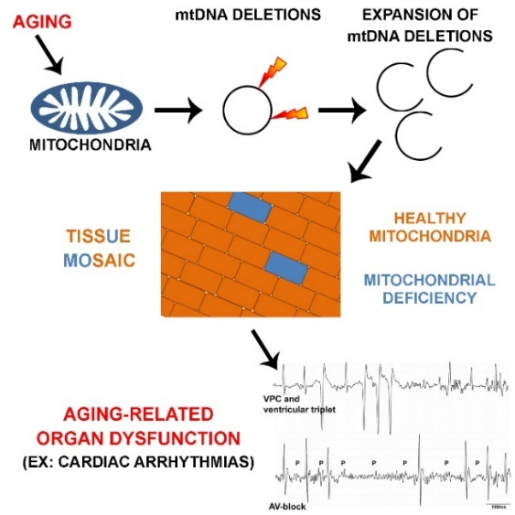

Baris OR, Ederer S, Neuhaus JF, von Kleist-Retzow JC, Wunderlich CM, Pal M, Wunderlich FT, Peeva V, Zsurka G, Kunz WS, Hickethier T, Bunck AC, Stöckigt F, Schrickel JW, Wiesner RJ. (2015) Mosaic Deficiency in Mitochondrial Oxidative Metabolism Promotes Cardiac Arrhythmia during Aging. Cell Metab. 21(5):667-77.

